**8-1 Assignment: Data Aggregation Pipeline**

Aaron Ciminelli

SNHU

CS-340-T3341 Client/Server Development 23EW3

Hari Paruchuri, Adjunct Professor (M.S, MBA)

February 26, 2023

1. **Creating Companies Database**

**a. Import**

1. cd /usr/local/datasets

2. /usr/local/bin/mongod_ctl start-noauth

3. mongoimport –port 39040 –db companies –collection research ./companies.json

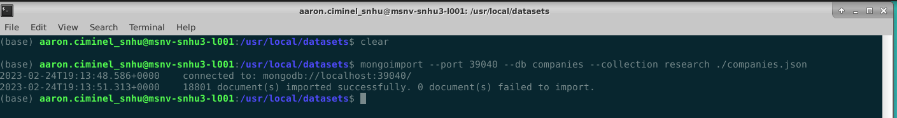

**b. Verify and Queries – “Advent”**

1. > use companies

2. > db.research.find({“name”: “Advent”})

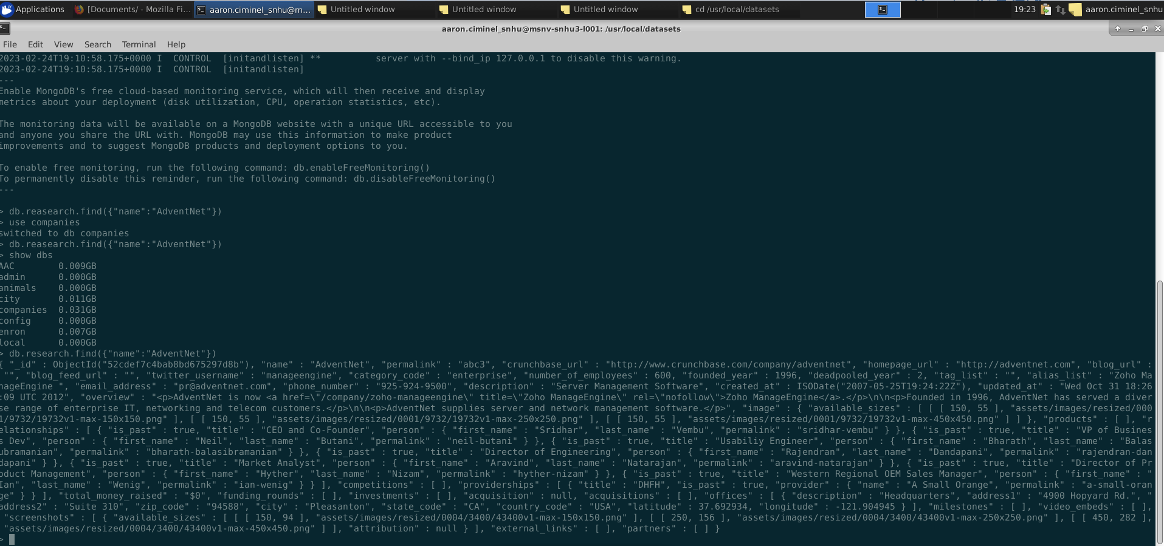

**c. Limit 10 – “founded year”**

> db.research.find({

…founded_year”: 1996},

…{“name”: 1}).limit(10)

1. **Using Mongo Queries**
2. **List only the first 20 names of companies founded after the year 2010, ordered alphabetically.**

> db.research.find({

…founded_year: {$gt: 2010}},

…{name: 1, _id: 0}).sort({name: 1}).limit(20)

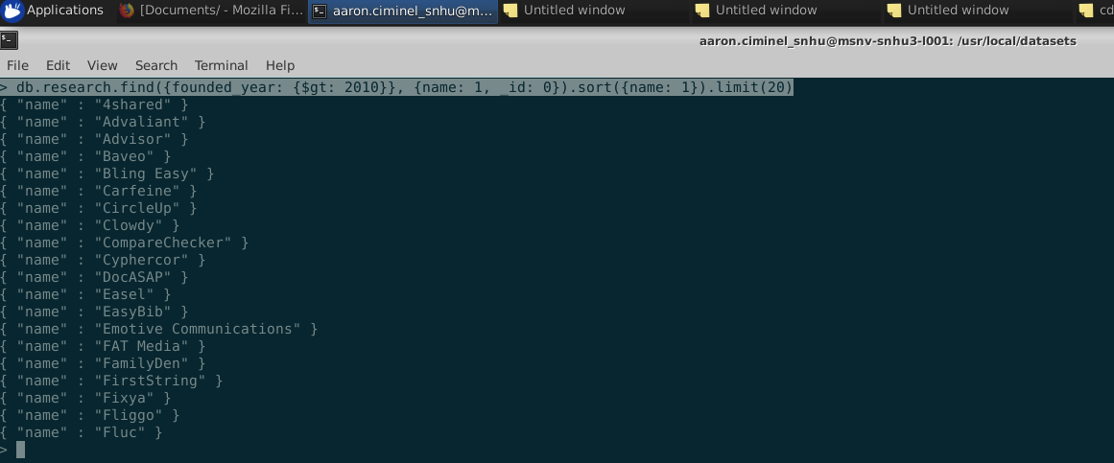

1. **List only the first 20 names of companies with offices in either California or Texas, ordered by the number of employees and sorted largest to smallest.**

> db.research.find(

… {

… $or: [

… { “offices.state_code”: “CA”},

… { “offices.state_code”: “TX”},

… ]

… },

… {name: 1, number_of_employees: 1, _id: 0}

… ).sort({number_of_employees: -1, name: 1}).limit(20)



1. **Design and implement a MongoDB aggregation pipeline**

> db.research.aggregate([

…{$unwind: “$offices” },

…{$match: {“offices.country_code”: “USA”}},

…{$group: { _id: “$offices.state_code”,

… total_employees: {$sum: “$number_of_employees”}

…}},

…{$sort: {_id: 1}}

…])

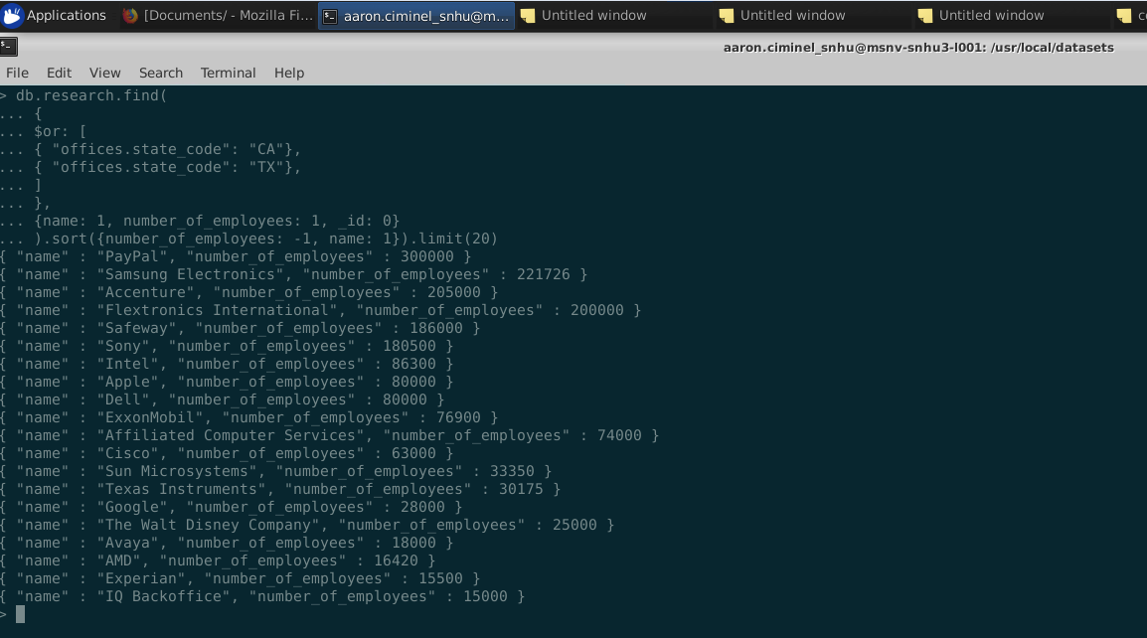

**Resources Used:**

1. [MongoDB Cheat Sheet | MongoDB](https://www.mongodb.com/developer/products/mongodb/cheat-sheet/#databases-and-collections)
2. [Aggregation Pipeline — MongoDB Manual](https://www.mongodb.com/docs/manual/core/aggregation-pipeline/)
3. [Introduction to the MongoDB Aggregation Framework | MongoDB](https://www.mongodb.com/developer/products/mongodb/introduction-aggregation-framework/)
4. [Mastering MongoDB 4.x : Expert Techniques to Run High-volume and Fault-tolerant Database Solutions Using MongoDB 4.x (snhu.edu)](https://eds-p-ebscohost-com.ezproxy.snhu.edu/eds/ebookviewer/ebook/bmxlYmtfXzIwOTQ3NjhfX0FO0?sid=0ef5e680-dd40-4c1d-9ae1-9518044518c5@redis&vid=0&format=EB&lpid=lp_147&rid=0)
5. [MongoDB Aggregation Pipelines (w3schools.com)](https://www.w3schools.com/mongodb/mongodb_aggregations_intro.php)